Zuhlsdorf Demystified
You can’t make this stuff up. Part III

True clericalism is an anomoly and abberation in that it engenders disdain and disrespect for others, especially those who are not clerics (ordained). Hence, real clericalism is when a deacon, priest or bishop has an attitude of superiority over his flock in that he believes he is 'better' than they are, whether spiritually, intellectually or otherwise. Clericalism patronizes and denigrates the unordained (laity). It seeks to be treated with privilege rather than seeking to be of service.
- Zuhlsdorf’s friend John Triglio of Black Biretta (1)

John Todd Zuhlsdorf has made an art form of trumpeting his clerical status and humanity ontologically higher than that of those not ordained to the priesthood. He leave no one in doubt that beneath the thin veneer of charity, he actually despises and regards as intrinsically inferior those who do not belong to the clerical caste system.
It is not just those who are non-ordained he despises, his blog betrays a breathtaking contempt for women and especially those religious women who belong to the LCWR. He’s terrified of all emotionally and intellectually independent females but he is thoroughly intimidated by religious women who not only do not live by his restrictive code of compliance but who are educated to a level beyond his wildest dreams and competence. Half of all North American female religious hold MAs in various disciplines and one quarter of these women has earned doctorates. Any one of them has probably forgotten more than Zuhlsdorf will ever learn! Interestingly, he hates being quizzed about his credentials to claim the level of authority and clout he exercises. With good reason!

A convenient arrangement
Zuhlsdorf, in his whimpish apologia pro vita sua type retort to Phyllis Zagano, provided only sketchy details about who he is and where he stands canonically in relation to the Catholic Church and its mission. He claims that he was ordained for the diocese of Villetri-Segni, an old suffragan See of the diocese of Rome. Vestigial dioceses like this provide a title for Curial Cardinals.
It is reasonable, however, to ask some basic questions about Zuhlsdorf’s claimed ministerial status and his relationship with the People of God. ‘Ordination’ in Catholic Theology and Law does not imply, signify and effect some kind of a-contextual automatic elevation of being to a higher level of existence without reference to mission. Only the most rigid, mechanistic scholastic sacramental theology would say otherwise. For what identifiable mission to and on behalf of the Catholic community was he ‘ordained’? It is clear that a number of people have queries and these with some probable cause. ‘Ordination’ is a commissioning and empowering for the mission at the service of Christ and the Church. For this to be recognisable and validated, it requires a clear authentic call from and approval by the Community. Even validity of ordination does not automatically effect grace in a semantic void. Ordination is not an end in itself. Zuhlsdorf thinks it is, that’s the way he thinks and acts. He is wrong.
Zuhlsdorf, by his own admission, has not lived in Rome for about a decade. He now resides permanently in the United States and well away from the Italian diocese of incardination. Up until very recently, it appears that he did not have any kind of Canonical relationship with a diocese in the USA. He claims now that this has changed and that he has been granted faculties by the bishop of Madison, Wisconsin.
I am not engaged in any official external apostolate where I live. I have no assignment. I haven’t sought anything on top of what I now do. I can barely make headway on my thesis as it is! (That would be right. He is not studying at all; he’s running a business full time.) Since I am not functioning publicly in any way as a priest within the diocese where I live, I do not need the faculties of the diocese and therefore I have not sought them. I have been in the diocese with the knowledge of the last two bishops of the place. I don’t know what the present bishop knows. I haven’t been in touch. (2)
This strange account of his canonical status plus the mysterious ten year absence from a permanent academic commitment at the Patristicum is all very odd.
Simply put, “Fr” Zuhlsdorf is licensed to celebrate certain Sacraments, at least in the diocese of Madison WI, but he is not missioned and committed to a normal on-going pastoral relationship between himself and local community. Without this essential mission, priesthood is sterile, ineffectual and thoroughly meaningless. The Canonical and Scholastic theological categories of ipso facto do not add up to an efficacious Sacrament. The validity of Zuhlsdorf’s ‘ordination’ may reasonably be not only questioned but even held in serious doubt.

Zuhlsdorf’s own New Evangelisation
He relies on a deeply embedded streak of Calvinism and fundamentalist protestant prosperity Gospel ethos to encourage and benefit from the free capitalist market. Zuhlsdorf reduces that equation to an expectation that his followers will make lots of money who, in turn, will pay a generous monetary tribute to him. He does this by cleverly manipulating the band of timid, guilt ridden disciples and camp-followers through a combination of Jansenist mind games, Pelagianism and clerical entitlement ploys.
The trick with playing the Jansenist card is to keep before his devotees their intrinsic rottenness, sinfulness and utter unworthiness before God. A favourite mantra is Go to Confession. He is not really interested in the Sacrament of Reconciliation for its own sake but rather the ongoing spiritual paralysis the guilt reminders cause and the consequent infantilised dependence of the simple people on the exclusive power of sacerdotal ministry. The justification for this piety is the neurotic spirituality of the Cure of Ars and Lacordaire.
Zuhlsdorf, whether consciously or not, has also mastered the art of projecting his own psycho- spiritual pathologies onto his fragile minded followers. The clinicians would be fascinated with the heavy transference and counter transference of psychoses, neuroses, fixations and fantasies going on in this rather bizarre and unhealthy relationship between Zuhlsdorf and his followers. There is nothing adult to be said about the dynamic.
Zuhlsdorf is also the complete Pelagian. He has recently vented very petulantly about Francis’ categorization of Trads by proclaiming: “I am a Self-Absorbed Promethean Neopelagian” (3)
That he is a Pelagian is clear from a business strategy, namely that there is no cheap grace. Everything in the end reduces to some form of barter either primitive or complex. What he gives in exchange for cash, gifts, perks are patronising stamps of approval on selected comments on the blog are random pious advice, gratuitous bullying and the odd portion of ecclesiastical Latin. He also frequently validates his theological, liturgical and life-style eccentricities with references to the Magisterial pronouncements of JP II and, above all, Benedict XVI, the Catechism of the Council of Trent, Church laws, customs, norms, rubrics. He seldom, if ever, mentions the fact that at the heart of it all Christianity is actually grounded in Jesus Christ and his Gospel. These considerations are not so good for business.
Unencumbered by a vow of religious poverty, he goes all out to avoid any suggestion of a frugal lifestyle. Zuhlsdorf’s Weltanschaung shares a great deal of common ground with the arrogant and intolerant populist bigots like his idol Rush Limbaugh and the Gordon Gecko Masters of the Universe Capitalists. As he frequently says: you can’t make this stuff up!
Zuhlsdorf has long been in the business of discrediting or dumbing down the authority of Vatican II. His tack now is to confect the propostion that Vat II can only be interpreted in the light of the Magisterium of JP II who, under his nom de plume/guerre, Joseph Ratzinger, did a great deal to limit or even dismantle some of the foundationally important gains of Vatican II, most notably collegiality.
Despite his own disinformation, Zuhlsdorf is not a professional theologian, liturgist or canon lawyer. Regardless of that, he has made a cottage industry out of conveniently distorting and reinterpreting Church Councils, doctrines and disciplines to his own ends. He describes this as his divine destiny, a essential ministry and the work of orthodoxy. As long as he can argue that he is an authority his naive disciples will believe him and pay him handsomely for the deception.
This asymmetrical arrangement is founded on the patronising premise that the lay people are ignorant, stupid peasants who should know their place, not question and be led as directed. It should be little wonder that he harbours an extra special contempt for laity and religious women who a clearly the authentic people of the Church than he is. He is consumed with resentment too over most of these dedicated people who are far more educated than he is. The resultant inferiority complex combined with the little man syndrome are compensated for by invoking the bizarre sacerdotal clericalist myth of the delusional St John Vianney, after God, the priest is everything.
Zuhldsorf thrives and flourishes in this kind of differentiated exclusive Gnotic cosmos where there are clear ontological markers which differentiate the territorial boundaries between the smelly sheep and the sterilized shepherd. Zuhlsdorf’s script and behaviour betray him as a snob, a name dropper, a brown-noser of epic proportions, a gossip, an indolent, pampered sook and a coward. He has become lost in the fog of his own self-confected mystique and mythos.

A constant reminder of the ontological chasm between those stamped with the indelible mark and those unfranked and how much money can be made out of it by the clerical entrepreneur:

ACTION ITEM for COURAGEOUS PRIESTS!
Posted on 30 May 2014 by Fr. John Zuhlsdorf
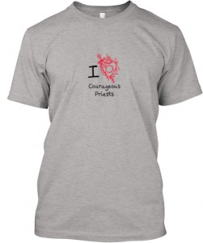Once again I am teaming up with Courageous Priests.
The people who have the blog Courageous Priest are trying to raise some money by selling t-shirts.
You get cool t-shirts with a good message, they get capital, and I get a percentage of the sale. Everyone wins.
There are three colors each, for men and for women.
This is a limited time offer: only until Thursday, 5 June.
They have a goal of 100. Let’s see if we can sell 1000 for them.

MEN’s shirts HERE
WOMEN’s shirts HERE

Lest anyone be confused about who is the most courageous of all priests here’s a clue,

Zuhlsdorf’s favourite T-shirt.

Search Fr. Z’s Blog: Yes, Hell is real

Zuhlsdorf goes apoplectic when he hears Francis say things like this:
“I prefer a Church which is bruised, hurting and dirty because it has been out on the streets, rather than a Church which is unhealthy from being confined and from clinging to its own security. I do not want a Church which is concerned with being at the centre and which then ends up by being caught up in a web of obsessions and procedures. If something should rightly disturb us and trouble our consciences, it is the fact that so many of our brothers and sisters are living without the strength, light and consolation born of friendship with Jesus Christ, without a community of faith to support them, without meaning and a goal in life. More than by fear of going astray, my hope is that we will be moved by the fear of being shut up within the structures which give us a false sense of security, within rules which make us harsh judges, within habits which make us feel safe, while at our door people are starving and Jesus does not tire of saying to us: ‘Give them something to eat.’” Evangelii Gaudium # 49
Zuhlsdorf has absolutely no insight into this dimension of the Gospel mainly because he has no insight into himself. He clearly rejects the Social teaching of the Catholic Church founded as it is in the preaching of Jesus, the ecclesiology in the Acts of the Apostles and the Social Encyclicals from Leo XIII down to the Apostolic Exhortation of Pope Francis. He has never been fully converted to Catholicism and continues to carry an enormous freight load of Calvinism with him and this blinds him to key Catholic understandings of Christ, Grace, Salvation and the Church. It is no wonder that he has no faith comprehension of the scope of global poverty and its root causes in unjust economic structures and institutions which maintain and enforce massive socio-economic disequilibrium. The poor don’t buy his trinkets or subsidies his version of easy street.
The sheer volume of hubris, premeditated orchestration of prejudice is breathtaking. And so is the scope of largess Zuhlsdorf gets in return to feed his sybaritic lifestyle, fictionalised by him to mean vitally important ministry.
The Consumer
Zuhlsdorf has proven his penchant for old ecclesiastical architecture especially of the Baroque era. He needs to tend further evidence of his enormous appetite for fine food, beverages and cigars. His blog is full of references to and pictures of exotic liturgical paraphernalia. He is fixated on this stuff. What he gives little or no indication of is an expansive, inclusive and effective priestly ministry where people are prioritised above rubrics.
In recent times Zuhlsdorf’s passion for self-publicity, self-indulgence, gourmet food, top shelf beverages, guns, ammo, high tech gizmos, far Right wing Tea party republican politics, Reagonomics and other consumables have turned people off him. Even close followers and admirers are realizing that he is a sybarite and a crass materialist who has transformed his wants into his needs. This translates into a shrinking sphere of influence in real terms as fewer and fewer people are prepared to subsidise his rampant ideology, his pampered lifestyle and his inflated sense of clerical entitlement.
What he really hates and dreads more than anything else is for his not so subtle petulant demands, gormandising and penchant for luxuries to be exposed. A commenter in the Sean Michael Winters’ NCR article cuts to the quick:
“The priest blogger, who posts using the first initial of his last name, has the gall to criticize the pope’s comments on the economy and the inequality of wealth distribution (in red ink, no less!) after a 20+ day jaunt to NYC, Rome, Venice wining and dining as indicated by the numerous pictures of the food and drink in which he indulged himself. At whose expense? His benefactors?
WHEN will someone call this priest on the carpet for such flagrant misuse of the priesthood for his own personal benefit? Better yet, who in the Vatican where he had a low level job a few years ago, is going along with him? Who told him that his lifestyle is how priesthood is defined?”
People are activating their
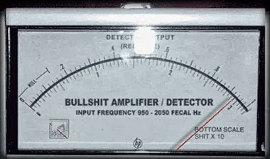

Zuhlsdorf’s pretences are being stripped away. It is not only those who normally oppose his positions on anything whatsoever who are becoming increasingly refusing to take him seriously as a disinterested, honest stakeholder in the life of the Catholic Church. A fellow cleric, totally disenchanted with the celebrity Zuhlsdorf even started a blog to counter the hubristic cash for trinkets entrepreneur. (3)
Mark Shea wrote a very telling little article in Patheos late last year entitled “Fr. Z seems to getting the knives out for Pope Francis” In picked up the hightened subterranean rage in Zuhlsdorf’s criticism of the Pope ever since his election. The intensity of his sarcasm, churlish criticisms and adolescent resentment has been revealed for what it truly is. (4). here

Sam Rocha too has joined in the criticism and launched a very strong attack on the shape-shifting, manipulative and self-absorbed Zuhlsdorf for the latter’s attack on Francis’ views on distributive justice.

Fr. Z Defies Pope Francis, With Merch
December 16, 2013 By Sam Rocha 59 Comments
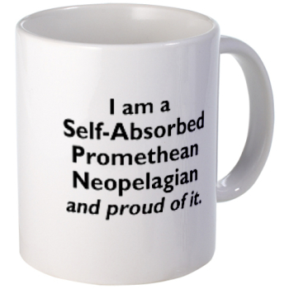
Fr. Z has stooped to a new low. He is selling cheap, bland, and ugly merchandise, generically built for quick and cheap profits, that does more than to merely invert or make light of paragraph 94 of Pope Francis’ recent exhortation, Evangelii Gaudium. Fr. Z goes further, by identifying himself, proudly, to be the very thing that the Pope decries (in Evangelii Gaudium) : (5) “The man needs to go do something priestly–like Francis–not make things worse by selling kitsch to help egg his readers on to still more Reactionary arrogance. This passive-aggressive BS is poison.”

Hard Identity Catholicism – Bullshit Amplifier Detector ON
Zuhlsdorf constantly employs the fear tactic as a control mechanism to maintain his following. Even the schismatic Rorate Caeli picks up on Zuhlsdorf’s fear hysteria. (6).

Source is (7) here
My View For Awhile: Bye for now, KC
Posted on 17 May 2014 by Fr. John Zuhlsdorf
It was a quick trip, too quick, but duty calls. – Duty = free travel, accommodation, best booze, food, live fire range and an appearance at an ecclesiastical drag queen convention.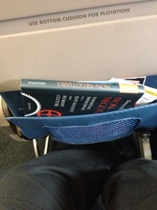 The sook Zuhlsdorf is in the air for 1 hour and 10 mins!!

As I leave Kansas City, I thank my amiable hosts, whose son was, today, ordained a deacon. They always try to provide the best for the weary clerical guest.
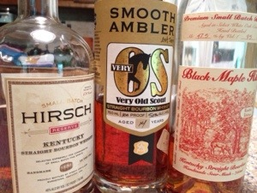
I wonder if many Catholics today haven't been cowed by the relentless secularism and relativism and even open anti-Catholic bigotry we find in the public square. We need a revitalization of our Catholic identity. – Zuhlsdorf, 31/05/14

Thanks to Fr. Fongemie of the FSSP at St. Rose Philippine Duchesne on the Kansas side. They gave me a great tour of their “new” church, which was a recovered Lutheran church.
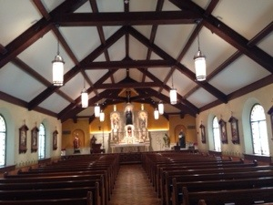

A wonderful rescued altar from a church in Scranton.
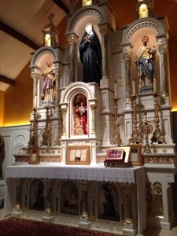

Then some of us did some shooting, which was a gas.
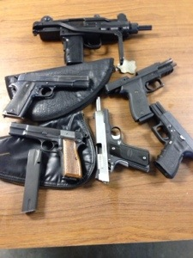
This was my first time to give a couple 1911s a try. I also enjoyed very much the Uzi, on full auto.
Later, we got out a real AK-47, an older one with the fully cast lower, and… the greatest pleasure of the day, an M1 Garand, Korean War vintage! When I heard that distinctive “ting” at the end, I said a prayer for vets who put their lives at risk overseas and hauled this rifle around over hill and dale, in bitter cold and savage heat, in boredom and terror, to protect our freedom and the lives of so many strangers. I want more time with that one someday.
A friend showed me a sampling of his collection of rescued relics. Astonishing.
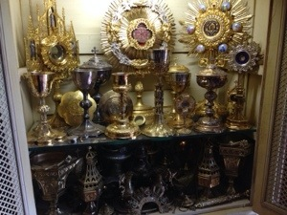
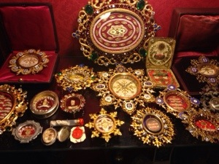
And…
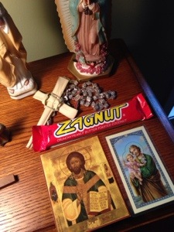
Oppps… sorry. That last one was at my other friend’s house. Got in there by accident.

This is what I wanted to post. One of St. John Vianney’s amices, which I once wore for Mass.

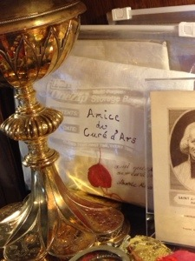
At the ordination, I had the pleasure of talking for a while with His Excellency Most Rev. Robert Finn, Bishop of Kansas City-St. Joseph. He is a real father to the seminarians and the younger priests of the diocese, who are growing in number. Very good men. I was impressed with them. In his sermon, Bp. Finn reminded the men never to doubt the power of supernatural graces as they fulfill their mission in the Church. Also, he told them that defilement and avarice are tantamount to the worship of a false god.
Bp. Finn was in good spirits after the ordination. We chatted about a mutual acquaintance, and had a chuckle or two. Finn has been indicted and convicted in court for not reporting a priest suspected of child pornography. He is still functioning as the bishop of Kansas City-St Joseph, Missouri. People of his diocese want the Vatican to conduct a thorough review of Finn (8) HERE.
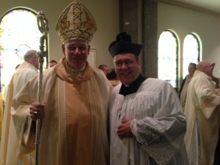

The new deacon, and two cold war warriors from the Compuserve days of the COL Forum!
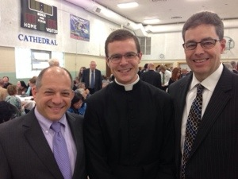

Finally, because everyone wants to know…. yes… BBQ!
The best I have ever had.
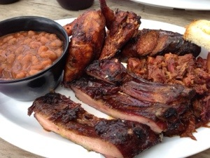

You can’t beat a sign like this:
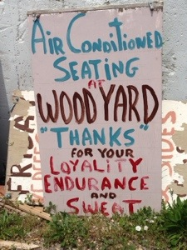
I look forward to my next stop in KC! (9) (Source is here)

Fr Z’s 2014 New Year Resolutions
Posted on 3 January 2014 by Fr. John Zuhlsdorf
Fr Z’s 2014 New Year Resolutions
1) Do even more to support the advancement of Summorum Pontificum.
2) Drink (sell) even more Mystic Monk Coffee.
3) Post even more on my blog.
4) Practice even more at the shooting range.
5) Offer even more of my services as a preacher and lecturer.
6) Read even more good books.
7) Travel even more to the UK and Rome.
8) Exercise even more.
9) Pray even more for my benefactors.
10) Cause even more “chaos” … as Pope Francis asked me to. ¡Vaya Lío!
As a corollary to #4 I am going to build an AR-15 from scratch.

You can help me stay in good practice.

Zuhlsdorf’s Italian self-indulgence Tour – The cutting edge of the New Evangelisation.

- Rome: Day 1 – settling back into it
- Posted on 24 April 2014 by Fr. John Zuhlsdorf
- I got settled in safely and soundly this morning and, for lunch, had caprese.
- 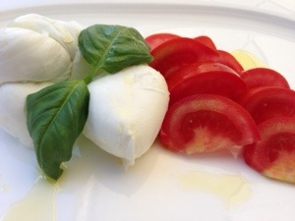

- Later in the afternoon I said Mass at the tomb of St. Philip Neri in the Chiesa Nuova. I will say Mass for the intention of my benefactors, you donors, tomorrow, late afternoon Rome Time.

- 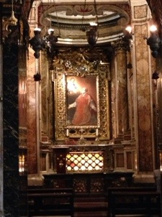

- I met with friends on the roof of the Minerva Hotel for a pre-prandial. Mine was campari soda.

- 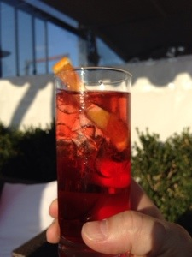

- It was great to see and spend time with Bp. Morlino here. As you can imagine, there are many bishops here. Bp. Morlino said that there would be as many as 700! It will look like a council.
- The view from one direction.

- 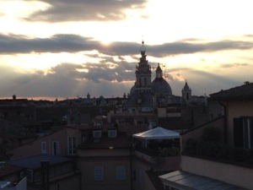
Top of Form
- Zuhlsdorf’s loyalty to the Pope and the Magisterium is selective. It only applies to the papacies of Popes before John XIII, then JP II and Benedict. He despises Francis. He confuses the Remnant, disregards rubrics, constantly refers to the poor, distributive justice, criticizes rampant Capitalism. He’s an inconvenient bad-for-business Pope!
Bottom of Form
- My small group went to Fortunato near the Pantheon for supper. While we were seated outside, a group of Portuguese students with their priest chaplain stopped and peered over the hedge by our table and asked if it was truly I, Fr. Z. I responded in the affirmative. We chatted for awhile and got a group shot or two. Really great young men, full of faith and energy. Portugal needs many more like these men!

- 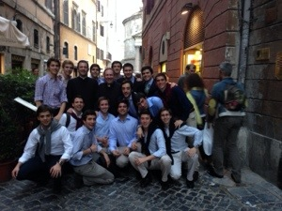

- Spaghetti alle vongole.

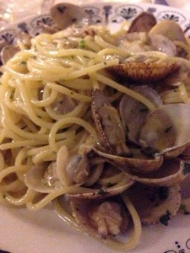

Oooooo.
- 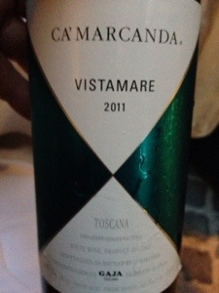
- Heading back to grab a cab and get some shut eye. Jet lag has taken hold! (An 8 hour flight is an extreme hardship for Zuhlsdorf for which he constantly craves sentiments of sympathy from the Remnant of the faithful!)

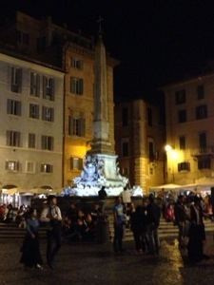

Do you use my blog often? Is it helpful to you? If so, please consider subscribing to send a monthly donation. That way I have steady income I can plan on, and you wind up regularly on my list of benefactors for whom I pray and for whom I periodically say Holy Mass.

And the following illustrate what the benefactors pay out in return for Zuhlsdorf’s “Holy Mass,” unctuous commentary and patronising pietisms.

Rome: Day 3 – more food, more churches, the usual
Posted on 26 April 2014 by Fr. John Zuhlsdorf

We had a late start today, which was welcome. Mass at S Maria della Scala. the sacristy situation was … just as Roman sacristies usually are, especially in the hands of religious. Anyone who has lived here knows exactly what I mean.
In no special order…
Something from lunch. Many of you will recognize what this is.
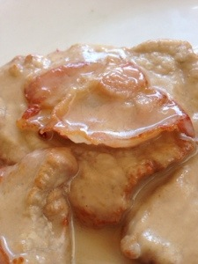
A brief visit to S Maria in Trastevere.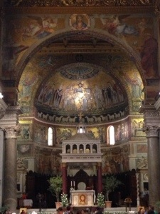

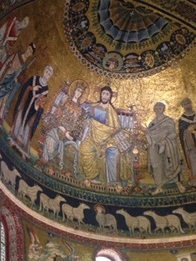

Okay… more food.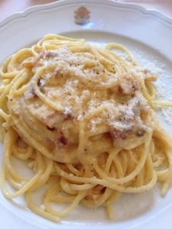
A pair of ancient Christian birds from a funerary monument fragment. There are many of these in the entrance way to S Maria in Trastevere.
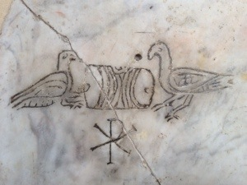

We darted up to S Pietro in Vincoli.

You know one. Moses by Michelangelo. It is said that, when he finished him, Michelangelo struck him with his hammer and said “Speak!”
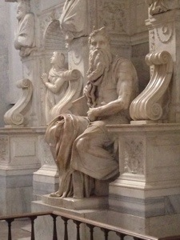

Chains of Peter in prison. They say there are also fragments of chains of St. Paul.
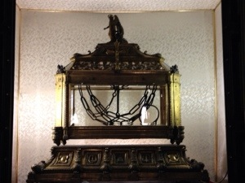

Over at S Prassede… a must see church near S Maria Maggiore, a fragment of the column of the flagellation.

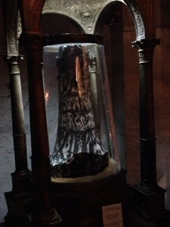

One of the great mosaics in the S Zeno chapel. Did you listen you my LENTCAzTs? I spoke about the Roman Stations each day and I described some of these things along the way.
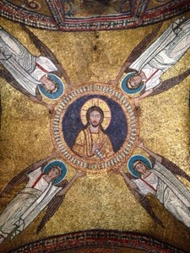
This is the mosaic that the weird sisters freak out about. The Pope honored his own mother, Theodora, with her image in the mosaic. She is still alive at the time it is made, thus the square, not round, “halo”. She is called “episcopa” NOT because she is a bishop – which is laughable – but because she is the mother of the Roman bishop! It is an honorary title… for the Pope’s Mom!
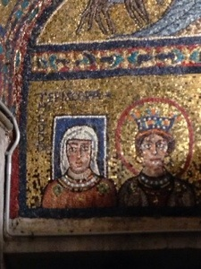
Less controversial were our antipasti tonight. A little of everything.
The Great Roman Fabrizio and his wife the Incredible Claudia joined us this evening, which truly made the evening special.
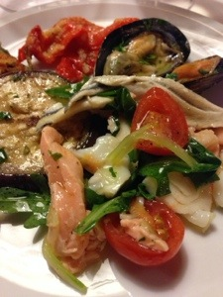
One of my favorite fishes: Orata.
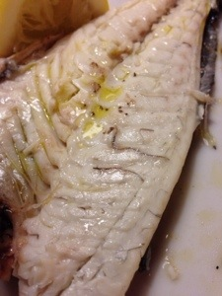
With His Excellency Bp. Paprocki, whom I met by happy chance. This guy is great.
Paprocki is also a member of the culture warrior clique in the US Bishops Conference. He is an active promoter of Exorcism and even declared a number of years ago that the very fact that the Press had begun to reveal the extent of clerical child rape was the work of the devil! Zuhlsdorf finds his native habitat with him and readily aligns himself with similar characters such as Olmstead, Finn, Conley and his predecessor Bruskewitz, Chaput, Morlino, along with other stellar performers in the New Evangelisation and standard bearers for Fortnights of Freedom. None of them know what to do with Francis except to say that most of what he has to say is lost in translation and he need, therefore, to be explained.
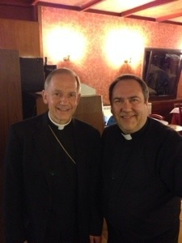 'Rome is full of odd priests' – A local saying!

Back to food. Baba al Rhum with little strawberries. Yes. This one can stay.

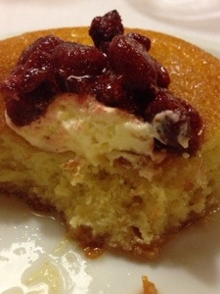
Most of the bottles removed, but it is still a worthy field of play.
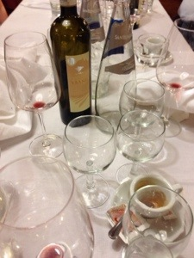
And thus endeth the day, with Compline, for this Saturday in alibis.

Some concluding thoughts

Zuhlsdorf continues to do what he does best and the only thing he is qualified to be. He is the quintessential clerical gossip, nag, pedant, dilettante, manipulative entrepreneur and, above all, an enormous bore. It is precisely these things, among others, which is of interest here.
It is clear that Zuhlsdorf watches the blogosphere closely and especially to those that place him under close scrutiny. Two things are a giveaway on his website: he has abandoned the old graphic depicting Francis being deconstructed and deciphered by the papal emeritus and he has taken to acknowledging his benefactors. Despite this it continues to be just as obvious that Zuhlsdorf: harbours deep resentment, anger and even hatred for Benedict for resigning the papacy. He and many of his disciples regarded the abdication as a kind of apostasy. Now his displaced anger and rage are directed at Frances.
It is manifestly obvious that he utterly despises Francis, dismissing him with the ad hominem peasant routine. Zuhldsorf, once in control of his little contained world of super orthodoxy has now to deal with a Pope who has shattered that world. Zuhlsdorf is bitterly resentful too that Francis, in word and deed and has exposed him by stripping away his pretences. Among these of course is his self-serving brag about being engaged in an indispensable apostolate. In fact, he is little more than an indolent sine-cure cleric who is a kept little man. He is a stunning example of sloth, presumption and, all the while, making a very comfortable living out of doing nothing.
What is already beginning to evolve is that growing numbers of people, even his own followers, are beginning to become acutely conscious of his narcissism, hubris, dissemblance, and manipulation. Added to that litany of suspicion are his inflated self-referencing, endless appeals to clerical entitlement and his evident crass, grasping materialism.
Things have now changed somewhat in Z’ rarefied atmosphere. The teaching and example of Francis has shown Zuhlsdorf up as a pretender and freeloader and increasingly large numbers of people are beginning to wake-up to this in a big way. It continues to be very clear that Zuhlsdorf while relying so desperately on them, he maintains a subterranean contempt for the laity, especially those, ironically, who continue to cash him up on gourmet food, drink, ammo for his armoury and for his other extensive ‘ongoing expenses.’
The trick is to force feed them on a diet of Hermeneutic of Comparison: contrasting in childish fashion ‘good’ Pope Benedict with ‘bad’ Pope Francis. This seems to work a treat and ensures the inflow of cash for the sybarite’s expenses. Zuhlsdorf makes a fortune and his disciples are maintained in their collective neurotic state: Keep them unthinking, unquestioning and utterly dependent as possible for as long as possible is the key to Zuhlsdorf’s success. A few insightful observes are twigging rather quickly now. A couple of posters in Patheos comment:
- ryan • 5 months ago
“When you have a blog constantly asking for gifts, money, donations, not to mention sales of coffee mugs, bumper stickers, prayers for "benefactors" (is a greedy priest really the one you want praying for you?), etc., it might bother you to have a superior who embraces poverty and humility .Just a thought.”
Martin Kelly • 5 months ago
“Mark, I stopped reading Zuhlsdorf years ago. It was the photographs of the nice meals that finally did it for me. He is a priest of the diocese of Rome, and might perhaps show a little more respect for his bishop. On the other hand, I have heard that that diocese has a saying about its own - that 'Rome is full of odd priests'.”
As long as Zuhlsdorf can convince his cult followers that true holiness, closeness to God are attainable only inside the sanctuary and can only be mediated to the less than holy by the sacrificial sacerdos communicating with God in a hieratic code, then he will remain in complete control. Gradually people are coming to the conclusion that God is not contained by the sanctuary that God’s fearful vindictive anger is not turned back by ornately draped liturgical line dancers muttering incantations in the coded dialects of road builders and brick layers. When they are all illuminated, Zuhlsdorf will no doubt move on and discover yet another colony of neurotics to exploit. Keep them miserable, morose, fearful, obsessively compulsive neurotic and dependent. That makes good business sense.
Zuhlsdorf shares a cheer squad of fawning disciples with a number of other eccentric so-called JPII New Movements. It is in journals published by some of these groups that extremist views are frequently expressed by plants who articulate the deep convictions of people like Zuhlsdorf who would otherwise be afraid to comment under his own name. One of these characters identifies himself as a sede-vacantist in the following post:
“There are still a few, born before the Vat II disaster who still cannot quite realise the utter mess the Church has got itself into. Maybe we were too trusting and it has taken time for the penny to drop.
The resurgence you mention is due to the belief amongst many that at last there is a non- Catholic pope, a pope of the new post-Vat II Church.
Pope Francis has done much to encourage this. His careless use of language has varied from being deeply damaging, to downright stupid and insulting.
If it’s an attempt to promote” thinking “, it’s a very dangerous game, already
lost.”
Zuhlsdorf, from his rants against Francis, insinuates more than a little sympathy with deeply disturbed characters such as the schismatic just quoted. It would be a real test of transparency and honesty on his part if Zuhlsdorf made it quite clear that he most strongly repudiates such views and proceeds to edit them out of his combox just as he does routinely with his critics. Compounding a sorry situation, one of Zuhlsdorf’s disciples across the Atlantic, the depressive Brit, Fr Ray Blake, regularly broadcasts similar censorious bleats about Francis on his blog. Neurotic abounds. His world of forlorn Trads closely resembles that of Zuhlsdorf in that Blake and his followers dine off one another’s pathologies.
A consequence for Zuhlsdorf is that, precisely because he is making constant carping, subversive and erosive comments about Pope Francis, many of his most loyal followers are distancing themselves from him and, disastrously for him, from the Donate button! Chances are that eventually he will imploded upon himself under the sheer weight of his own hubris, dissemblance and greed.

Endnotes
- Black Biretta’s John Trigilio authored the piece on Clericalism linked here. He had earlier penned a rather reactive piece in response to a criticism of the clerical sub-culture, It is linked here
- Zuhlsdorf responds to Zagano here.
- Zuhlsdorf’s rage at being effectively tagged a Pelagian, here. See here for sarcasm and ridicule at Zuhlsdorf merchandising his anger, here.
- Late 2013, Mark Shea wrote an article in Patheos which typified an growing mood of hostility towards Zuhlsdorf. Linked here A comment about Zuhlsdorf like this one is not uncommon: Not just a hypocrite, but an obnoxious, fat, bitchy, queeny hypocrite. Sam Rocha also reflects this growing hermeneutic of suspicion about Zuhlsdorf when he gave him a long overdue serve. Linked here Even the far outer fringe Rorate Caeli attacks Zuhlsdorf of scaremongering. See Here.
- More on Zuhlsdorf’s clericalist self-adoration and self-referencing here and here. It’s precisely items like these or belting the LCWR or altar girls that cause an enormous spike in his donate meter. Zuhlsdorf hubris on LCWR conforming to the prevailing ethos of the secular world. Zuhlsdorf holds the LCWR in utter contempt in particular and despises women in general HERE
- A Rorate Caeli blog criticising Zuhlsdorf for being a scaremonger, Here
- Zuhlsdorf’s junket to Kansas City for a Trad fest. Source is here For more of the same, look at his new year’s resolutions: Zuhlsdorf provides a graphic insight into the world of his values and priorities, see here A support link is HERE.
- Zuhlsdorf launches into Pope Francis’ address to the UN on redistribution of wealth, here.
- “What does the priest actually do all day?” Fr D’s Blog, here.

- Ron Conte jnr linked here.

- See this comment in Ray Blake’s blog here

David Timbs writes from Melbourne, Victoria, Australia.
01/06/14
Zuhlsdorf I HERE; II HERE

